**GPC Recognition Intervention EYFS-Year 3**

***This intervention involves deliberate over -learning, re-teaching and repeated exposure. This intervention can be used to address any gaps.***

***The session has 5 distinct parts.***

**1 Review**

* **Select 12 grapheme flashcards that the pupil should already know – based on your recent assessment.**
* **Show the child the flashcards and ask them to say the phoneme.**

*If the child is unsure, you can model reading the sounds using ‘Me, then you’.* *Make sure that the child is producing the pure sound and not schwarring (adding “er”) to the end of the sound. Make sure that they are positioning their tongue and mouth correctly to make the correct sound – you can model this for them.*

**2 Teach**

* **Explain that you will now be focusing on one new grapheme/phoneme.**
* **Explain that you shall say it first and then they will repeat it – using Me then you say the new phoneme for the child. The child repeats. Repeat this multiple times.**
* **Now introduce the grapheme flashcard – say the phoneme. Repeat multiple times.**
* **Show the picture and mnemonic on the back of the card. Read it to the child**
* **Place the card on the table and model running your finger over the grapheme whilst saying the sound. The child then repeats this.**

*Make sure that the child is producing the pure sound and not adding “er” to the end of the sound. Make sure that they are positioning their tongue and mouth correctly to make the correct sound – you can model this for them.*

**3 Practise**

* **Explain that you are now going to read some words containing the new grapheme.**
* **Use the sound tiles to build a word from the word list.**
* **Once you have built the word, identify the focus grapheme by pointing at it.**
* **Then point at each grapheme in the word as you say the phoneme.**
* **Model sound talking the words using robot arms and then blend using blending hand. The child repeats this.**
* **Repeat this process with more words from the word list.**

*You can choose to use as many words as you feel appropriate. If the child is able, you can reverse this process and read a word from the word list and ask the child to build that word for you. Use the spelling sequence to support this.*

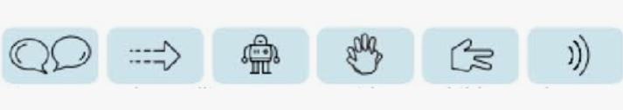

**4 Apply**

*In the pack you will find a decodable reader. This book will contain sentences that have words with the new grapheme, known graphemes and known HRS words. You can read some of the sentences for the child and stop when you reach a sentence containing the focus grapheme The child needs to read between 3-5 sentences*

* **Show the child the focus grapheme flashcard and ask them to say the phoneme. Leave it in front of them on the table.**
* **Explain that now they will apply the focus grapheme that they have learned to read a book.**
* **Hand them the book and remind them that they can use robot arms and blending hands.**
* **The child reads the sentences that contain the focus grapheme nb (not necessarily the whole book).**

**5 Review**

* **Show the focus grapheme and using ‘Me, then you’ to model saying the sound.**
* **Show the focus grapheme throughout the day and ask the child to say the sound.**